Chapter 4

IMPLEMENTATION

4.1 FRONT END AND BACK END USED

SYSTEM REQUIREMENTS
Software requirement:-
- Front End tools: HTML, CSS, PHP
- Back End tools: phpmyadmin
- Browser that supports HTML
- apache server
- MySQL database
- Xampp server

Hardware requirement:-
- CPU: Pentium processor and above
- RAM: 2 GB
- HDD: 40 GB

4.2 FUNCTIONAL REQUIREMENTS
HTML
Hypertext Markup Language (HTML) is the standard markup language for creating web pages and web applications. With Cascading Style Sheets (CSS) and JavaScript it forms a triad of cornerstone technologies for the World Wide Web. Web browsers receive HTML documents from a web server or from local storage and render them into multimedia web pages. HTML describes the structure of a web page semantically and originally included cues for the appearance of the document.
HTML elements are the building blocks of HTML pages. With HTML constructs, images and other objects, such as interactive forms, may be embedded into the rendered page. It provides a means to create structured documents by denoting structural semantics for text such as headings, paragraphs, lists, links, quotes and other items. HTML elements are delineated by tags, written using angle brackets. Tags such as <img /> and <input /> introduce content into the page directly. Others such as <p>...</p> surround and provide information about document text and may include other tags as sub-elements. Browsers do not display the HTML tags, but use them to interpret the content of the page.
CSS
Cascading Style Sheets (CSS) is a style sheet language used for describing the presentation of a document written in a markup language. Although most often used to set the visual style of web pages and user interfaces written in HTML and XHTML, the language can be applied to any XML document, including plain XML, SVG and XUL, and is applicable to rendering in speech, or on other media. Along with HTML and JavaScript, CSS is a cornerstone technology used by most websites to create visually engaging webpages, user interfaces for web applications, and user interfaces for many mobile applications.
CSS is designed primarily to enable the separation of presentation and content, including aspects such as the layout, colours, and fonts. This separation can improve content accessibility, provide more flexibility and control in the specification of presentation characteristics, enable multiple HTML pages to share formatting by specifying the relevant CSS in a separate .css file, and reduce complexity and repetition in the structural content.
PHP Language
PHP is a server-side scripting language designed primarily for web development but also used as a general-purpose programming language. Originally created by Rasmus Lerdorf in 1994, the PHP reference implementation is now produced by The PHP Development Team. PHP originally stood for Personal Home Page, but it now stands for the recursive acronym PHP: Hypertext Preprocessor.
PHP code may be embedded into HTML or HTML5 markup, or it can be used in combination with various web template systems, web content management systems and web frameworks. PHP code is usually processed by a PHP interpreter implemented as a module in the web server or as a Common Gateway Interface (CGI) executable. The web server software combines the results of the interpreted and executed PHP code, which may be any type of data, including images, with the generated web page. PHP code may also be executed with a command-line interface (CLI) and can be used to implement standalone graphical applications.
The standard PHP interpreter, powered by the Zend Engine, is free software released under the PHP License. PHP has been widely ported and can be deployed on most web servers on almost every operating system and platform, free of charge.
The PHP language evolved without a written formal specification or standard until 2014, leaving the canonical PHP interpreter as a de facto standard. Since 2014 work has gone on to create a formal PHP specification.
PHP development began in 1995 when Rasmus Lerdorf wrote several Common Gateway Interface (CGI) programs in C, which he used to maintain his personal homepage. He extended them to work with web forms and to communicate with databases, and called this implementation "Personal Home Page/Forms Interpreter" or PHP/FI.
PHP/FI could help to build simple, dynamic web applications. To accelerate bug reporting and to improve the code, Lerdorf initially announced the release of PHP/FI as "Personal Home Page Tools (PHP Tools) version 1.0" on the Usenet discussion group on June 8, 1995 This release already had the basic functionality that PHP has as of 2013. This included Perl-like variables, form handling, and the ability to embed HTML. The syntax resembled that of Perl but was simpler, more limited and less consistent.
Apache Server
Apache HTTP Server, colloquially called Apache, is free and open-source cross-platform web server software, released under the terms of Apache License 2.0. Apache is developed and maintained by an open community of developers under the auspices of the Apache Software Foundation.
Apache supports a variety of features, many implemented as compiled modules which extend the core functionality. These can range from server-side programming language support to authentication schemes. Some common language interfaces support Perl, Python, Tcl, and PHP. Popular authentication modules include mod_access, mod_auth, mod_digest, and mod_auth_digest, the successor to mod_digest. A sample of other features include Secure Sockets Layer and Transport Layer Security support (mod_ssl), a proxy module (mod_proxy), a URL rewriting module (mod_rewrite), custom log files (mod_log_config), and filtering support (mod_include and mod_ext_filter).
Popular compression methods on Apache include the external extension module, mod_gzip, implemented to help with reduction of the size (weight) of Web pages served over HTTP. ModSecurity is an open source intrusion detection and prevention engine for Web applications. Apache logs can be analyzed through a Web browser using free scripts, such as AWStats/W3Perl or Visitors.
Virtual hosting allows one Apache installation to serve many different Web sites. For example, one machine with one Apache installation could simultaneously serve www.example.com, www.example.org, test47.test-server.example.edu, etc.
Apache features configurable error messages, DBMS-based authentication databases, and content negotiation. It is also supported by several graphical user interfaces (GUIs).
It supports password authentication and digital certificate authentication. Because the source code is freely available, anyone can adapt the server for specific needs, and there is a large public library of Apache add-ons.
MySQL Database
MySQL is a Relational Database Management System (RDBMS). MySQL server can manage many databases at the same time. In fact, many people might have different databases managed by a single MySQL server. Each database consists of a structure to hold the data and the data itself. A data-base can exist without data, only a structure, be totally empty, twiddling its thumbs and waiting for data to be stored in it.
Data in a database is stored in one or more tables. You must create the data-base and the tables before you can add any data to the database. First you create the empty database. Then you add empty tables to the database. Database tables are organized like other tables that you’re used in rows and columns. Each row represents an entity in the database, such as a customer, a book, or a project. Each column contains an item of information about the entity, such as a customer name, a book name, or a project start date. The place where a particular row and column intersect, the individual cell of the table, is called a field. Tables in databases can be related. Often a row in one table is related to several rows in another table. For instance, you might have a database containing data about books you own. You would have a book table and an author table. One row in the author table might contain information about the author of several books in the book table. When tables are related, you include a column in one table to hold data that matches data in the column of another table
Xampp Server
Xampp server installs a complete and ready-to-use development environment. Xampp server allows you to fit your needs and allows you to setup a local server with the same characteristics as your production.
In case of setting up the server and PHP on your own, you have two choices for the method of connecting PHP to the server. For many servers PHP has a direct module interface (also called SAPI). These servers include Apache, Microsoft Internet Information Server, Netscape and iPlanet servers. Many other servers have support for ISAPI, the Microsoft module interface (OmniHTTPd for example). If PHP has no module support for your web server, you can always use it as a CGI or FastCGI processor. This means you set up your server to use the CGI executable of PHP to process all PHP file requests on the server.
4.3 DISCUSSION OF CODE SEGEMNTS
We have used the following code segments in our mini project:
LOGIN PAGE
<?php
$servername = "localhost";
$username = "root";
$password = "";
$dbname = "ars_cartrade";
// Create connection
$conn = new mysqli($servername, $username, $password,$dbname);
// Check connection
if ($conn->connect_error) {
die("Connection failed: " . $conn->connect_error);
}
$cardname=$_POST['cardname'];
$cardnumber=$_POST['cardnumber'];
$exp=$_POST['expmonth'];
$cvv=$_POST['cvv'];
$sql="INSERT INTO payment values('$cardname','$cvv','$cardnumber','$exp')";
$conn->query($sql);
echo "payment done!";
?>
</body>
</html>

INSERTION PAGE
<?php
$servername = "localhost";
$username = "root";
$password = "";
$dbname = "ars_cartrade";
// Create connection
$conn = new mysqli($servername, $username, $password,$dbname);
// Check connection
if ($conn->connect_error) {
die("Connection failed: " . $conn->connect_error);
}
$brand=$_POST['brand'];
$vehicletype=$_POST['vehicletype'];
$carname=$_POST['carname'];
$transtype=$_POST['transtype'];
$colour=$_POST['colour'];
$mileage=$_POST['mileage'];
$price=$_POST['price'];
$sql="INSERT INTO car (car_name,car_brand,vehicle_type,trans_type,mileage,colour,price)
VALUES('$carname','$brand','$vehicletype','$transtype','$mileage','$colour','$price')";
if ($conn->query($sql) === TRUE) {
echo "New record created successfully";
} else {
echo "Error: " . $sql . "<br>" . $conn->error;
}
?>

SELECTION PAGE
// Create connection
$conn = new mysqli($servername, $username, $password,$dbname);
// Check connection
if ($conn->connect_error) {
die("Connection failed: " . $conn->connect_error);
}
$brand=$_POST['brand'];
$vehicletype=$_POST['vehicletype'];
$sql="SELECT * FROM car where vehicle_type='$vehicletype' AND car_brand='$brand'";
$result=$conn->query($sql);

4.4 SNAPSHOTS OF CAR TRADING SYSTEM

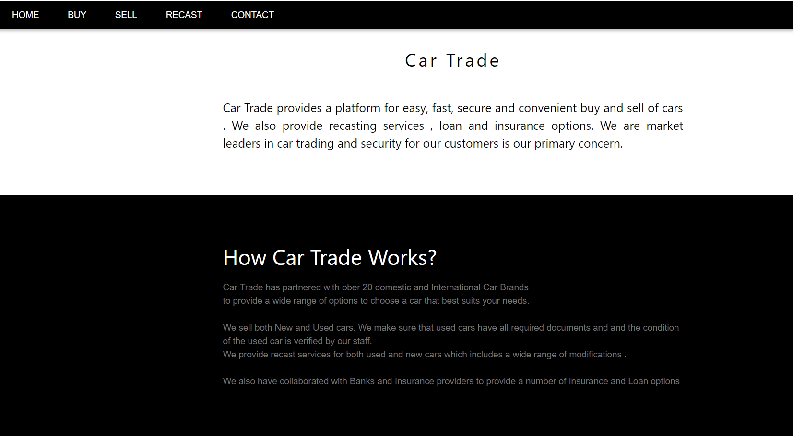
Fig 4.1 Welcome Page
The above figure 4.1 shows the welcome page of our project that provides the various options present in the project.
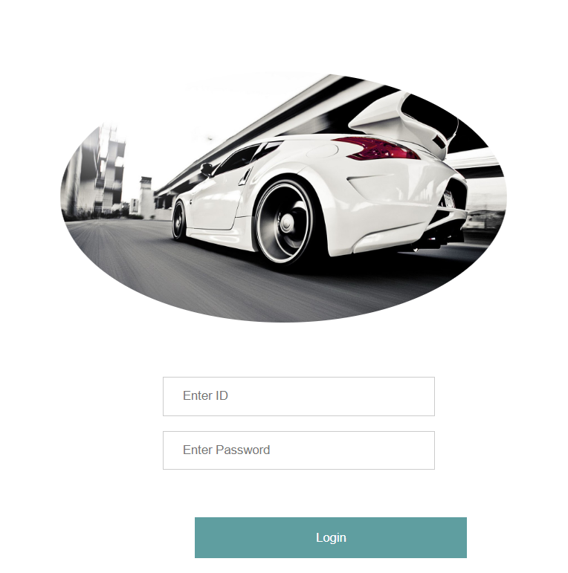
Fig 4.2 Login Page
The above figure 4.2 shows the login page for the user where the user enters the name and password.

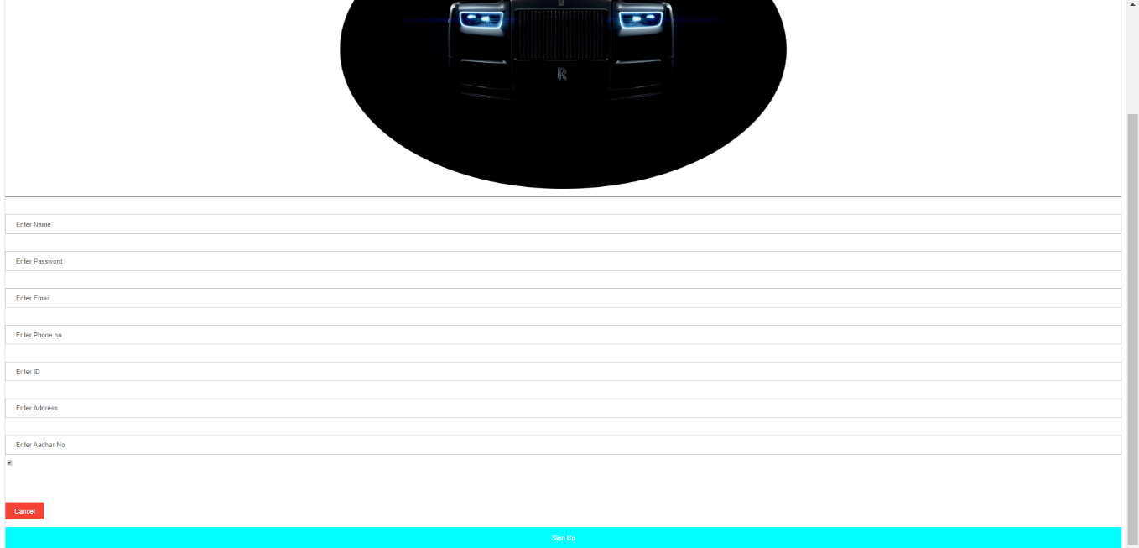
Fig 4.3 Signup Page
The above figure 4.3 shows the signup page for the user where he can create new id after providing the required details.

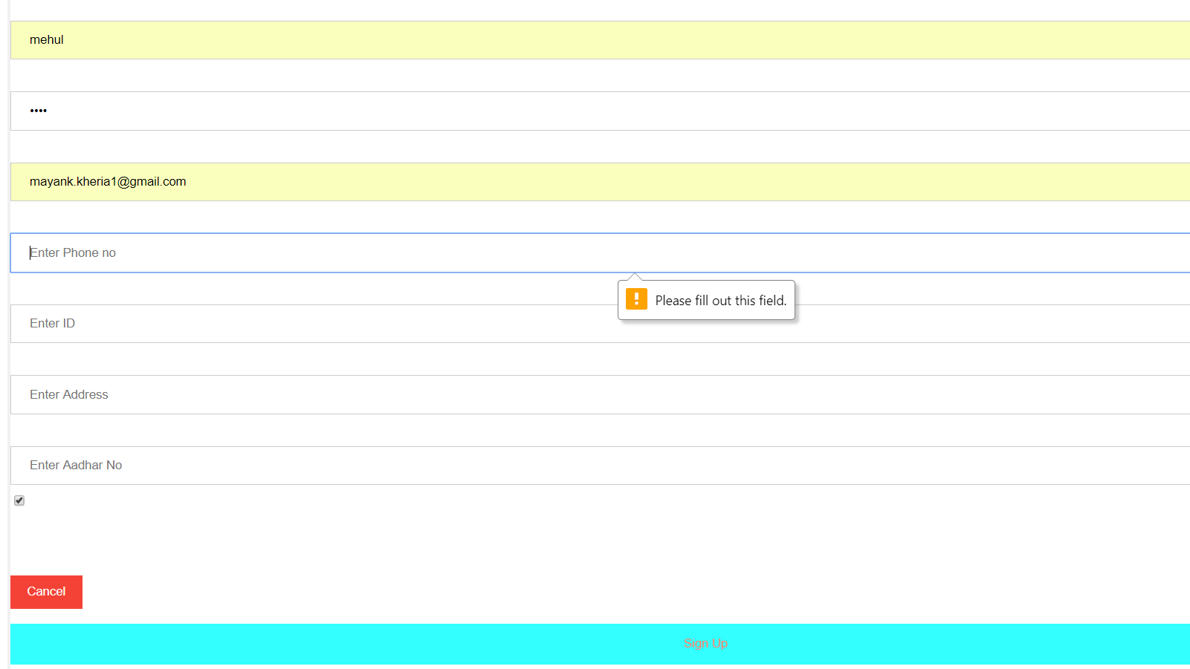
Fig 4.4 Trigger Description
The above figure 4.4 shows how trigger are used in case any required field is left blank by the user while signing up.

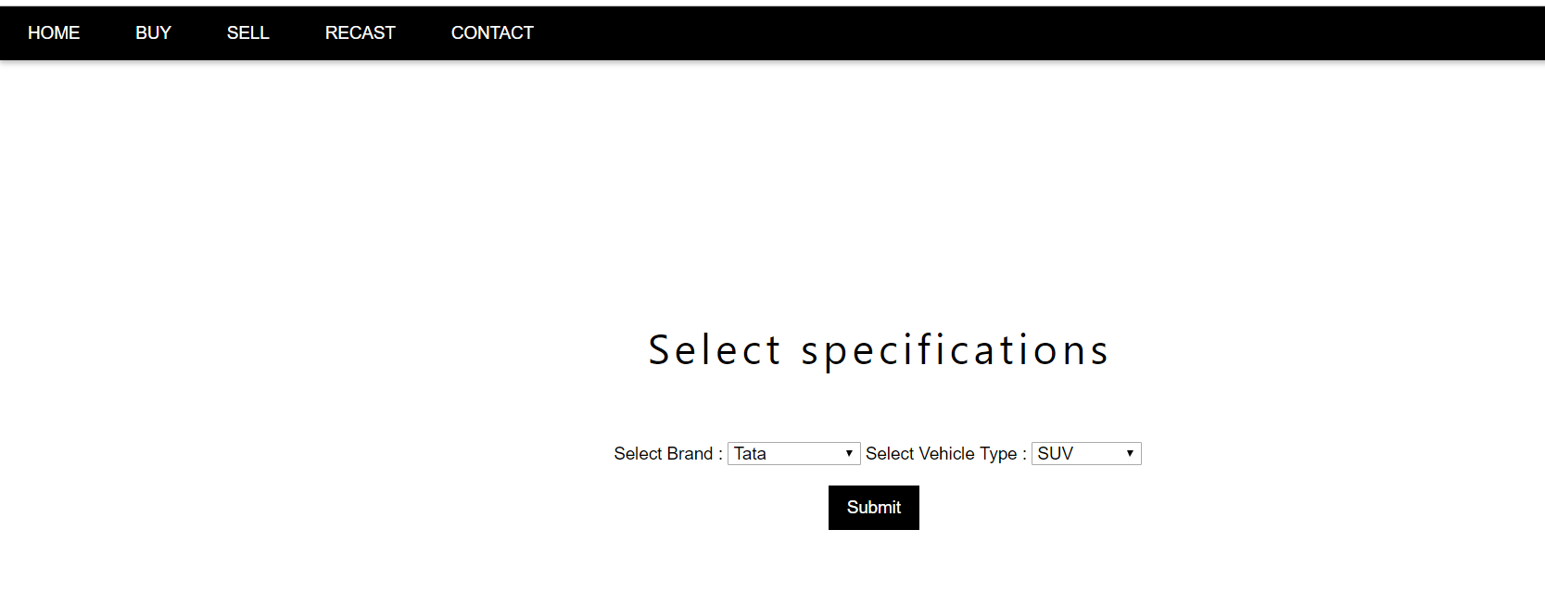
Fig 4.5 Car Buying Page
The above figure 4.5 shows the page that tell us about the various car buying options available with the user.

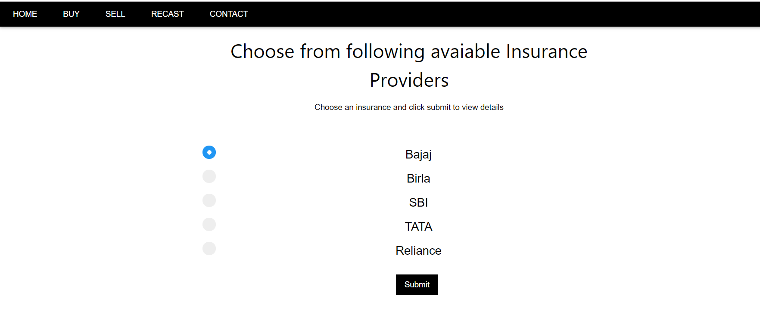
Fig 4.6 Insurance Details
The above figure 4.6 shows the page that tell us about the various car insurance options available with the user while buying a new car.

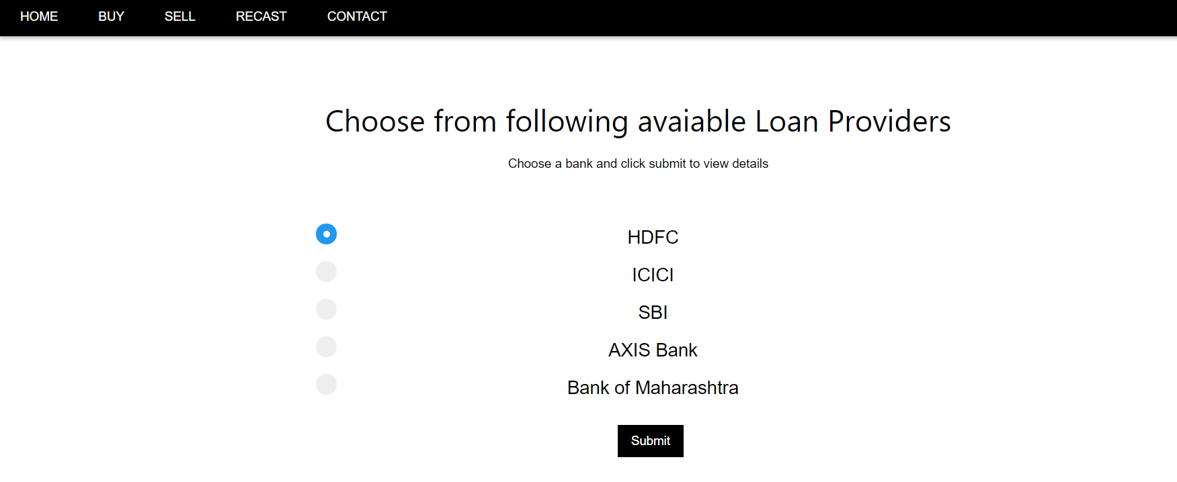
Fig 4.7 Loan Options Page
The above figure 4.7 shows the page that tell us about the various loan options available with the user while buying a new car.

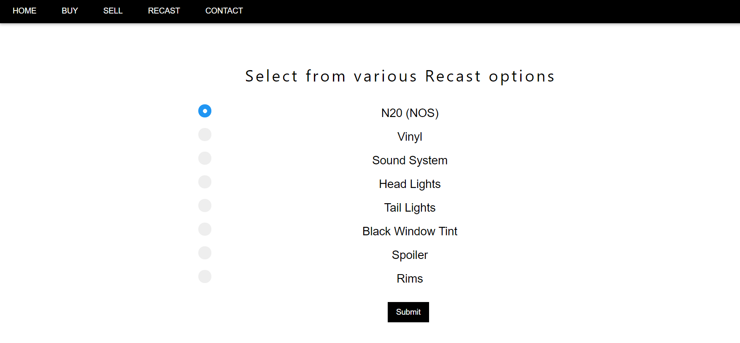
Fig 4.8 Recast Options Page
The above figure 4.8 shows the page that tell us about the various recast options available with the user while buying a new car.

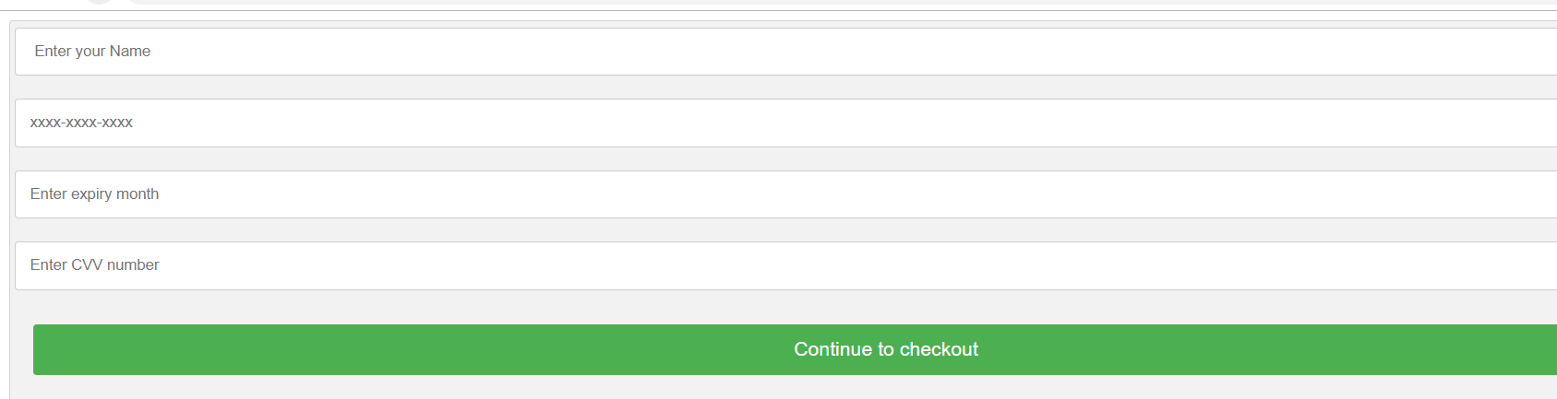
Fig 4.9 Payment Details
The above figure 4.9 shows the page that tell us about the various car payment options available with the user while paying for a new car.

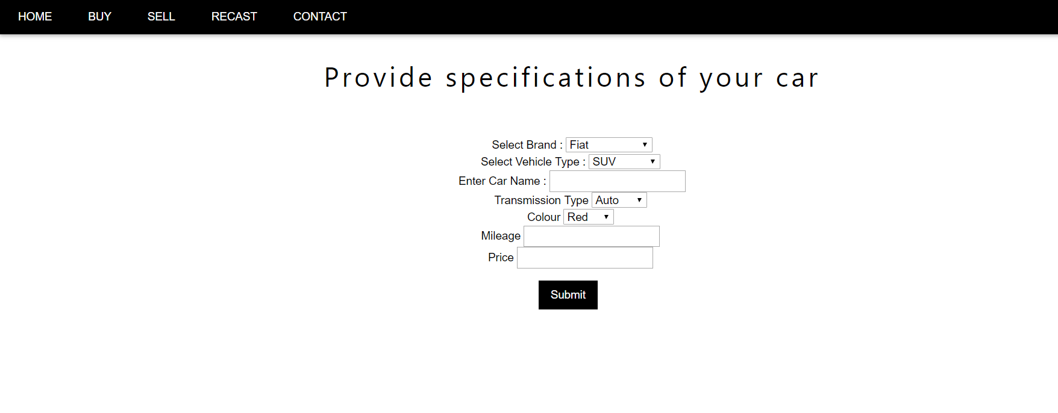
Fig 4.10 Car Selling Page
The above figure 4.10 shows the page that tell us about the various car selling options available with the user.

